Azamat Salamatov

Doctor Tai Cleveland

COMP 3324

Week 7 – Lab – Linux Command Injection

3/21/2023

Linux Command Injection

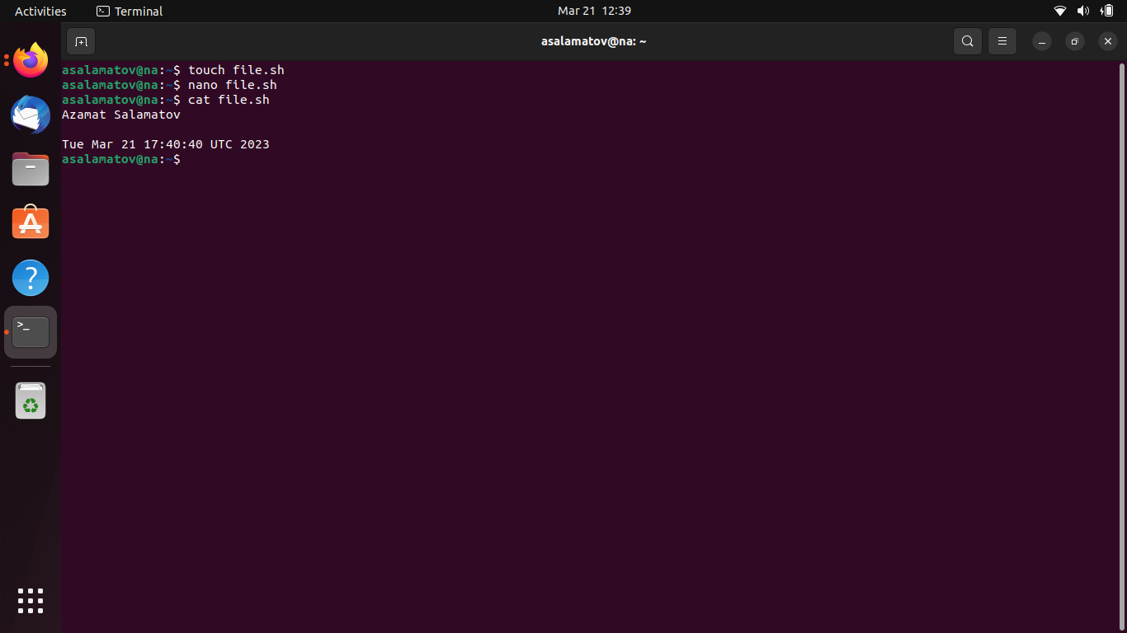

# I downloaded Ubuntu Linux a day ago

* Now it works perfectly fine
* I learnt lots of commands both for linux bash and python automation
* I also know how to create/detele files/directories, git, settings
* I downloaded python3 for automating of some IT responsibilities.